TASK 7.1P

Creating a Highly Available Environment

**Task 1: Inspecting Your VPC**

In this task, I reviewed the pre-configured Virtual Private Cloud (VPC) and its components. The VPC included public and private subnets across two Availability Zones, an internet gateway for public subnets, a NAT gateway for outbound internet access from private subnets, and an Amazon RDS instance located within a private subnet. This inspection helped me understand the network architecture, including routing tables, network ACLs, and existing security groups. The key takeaway was to ensure that only required components have internet access while maintaining private communication between tiers.

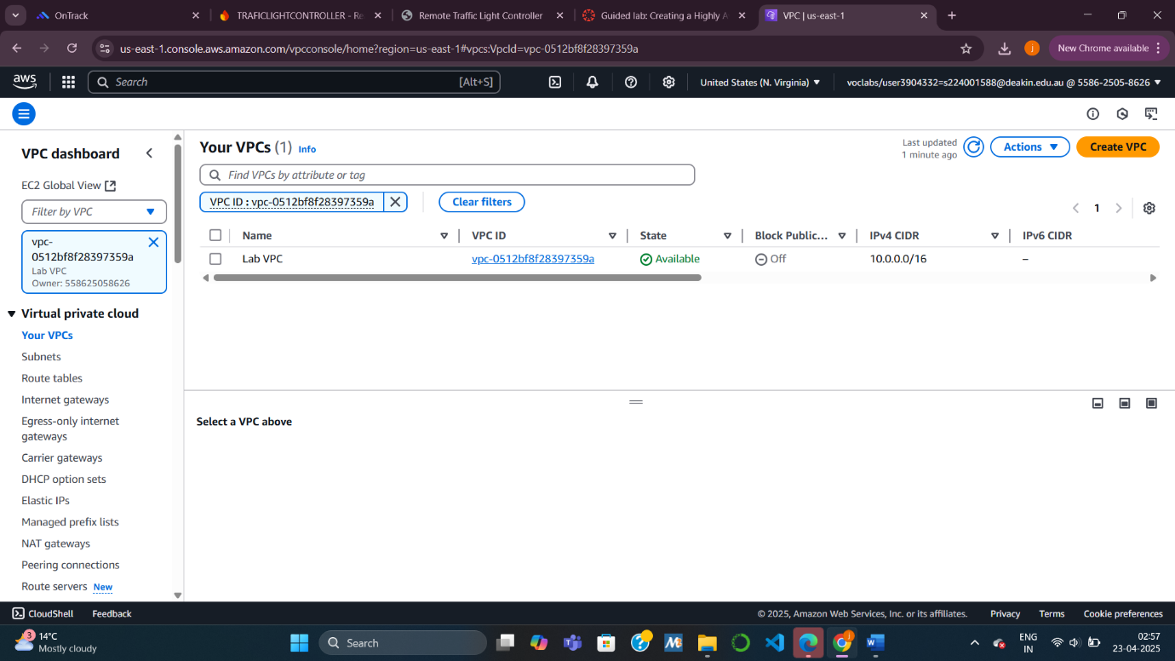

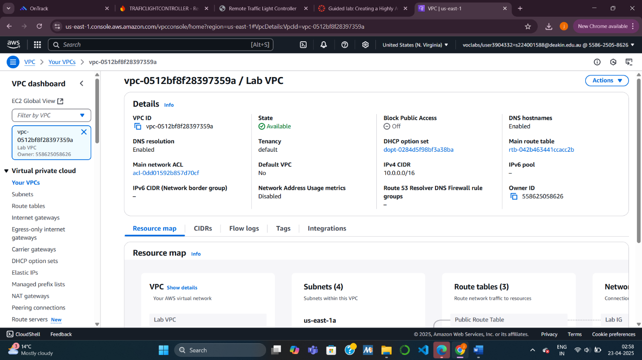

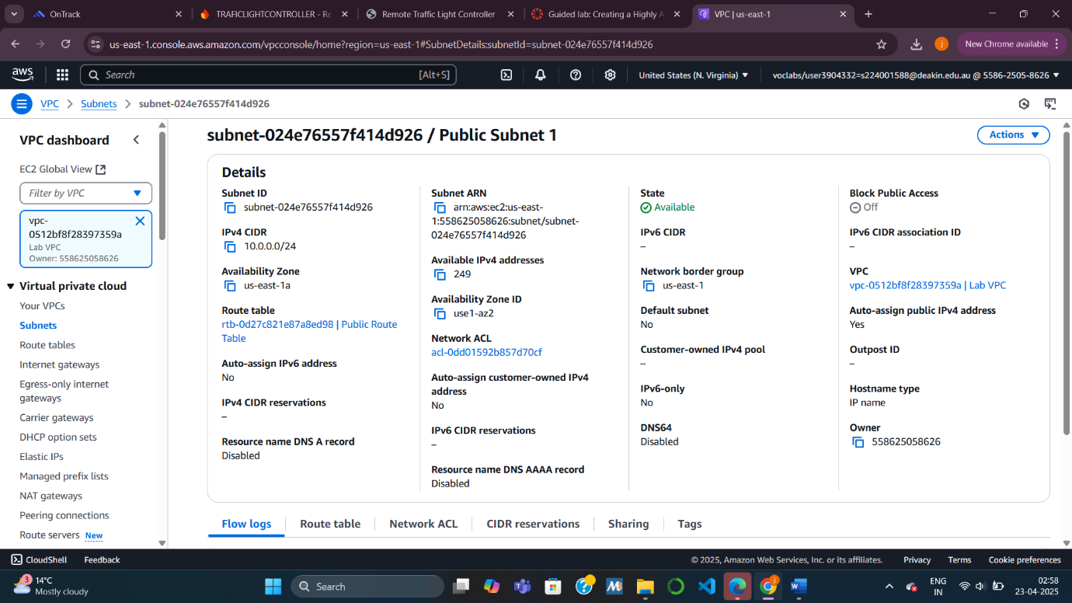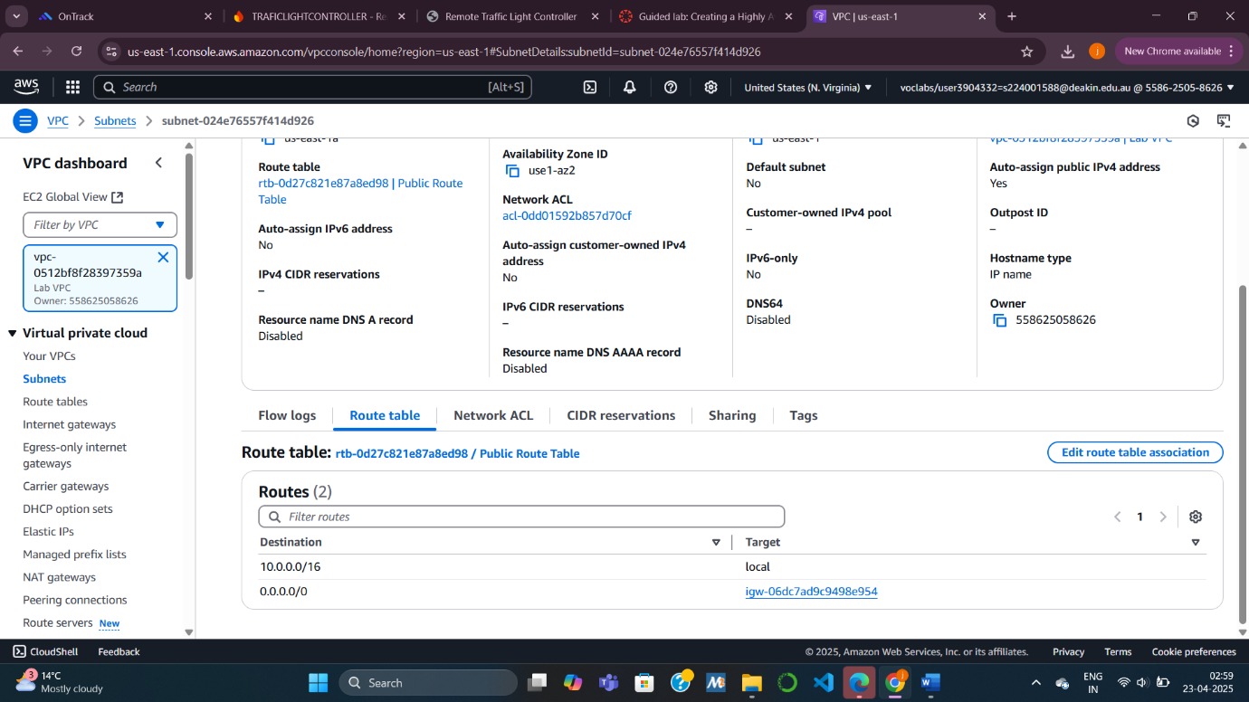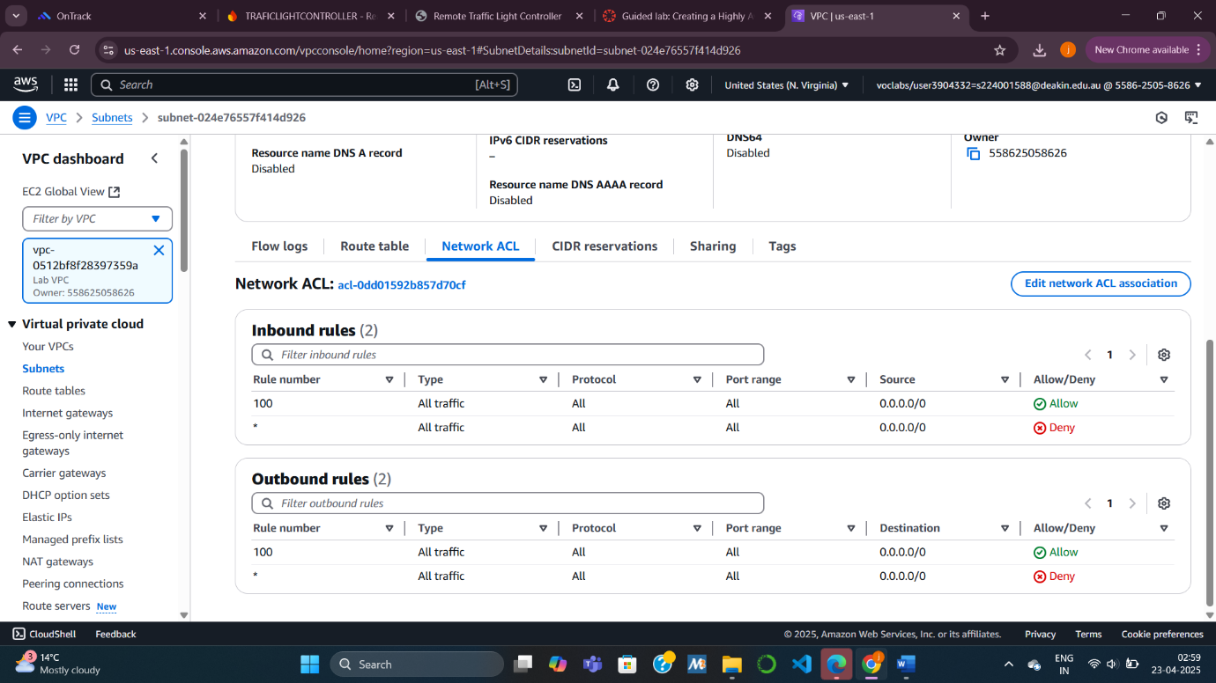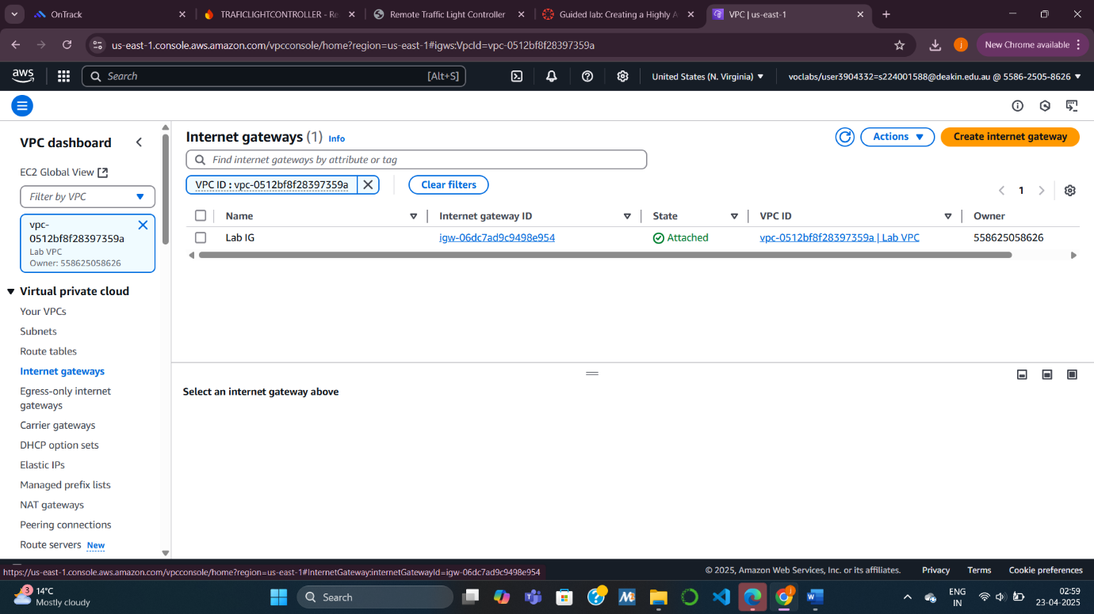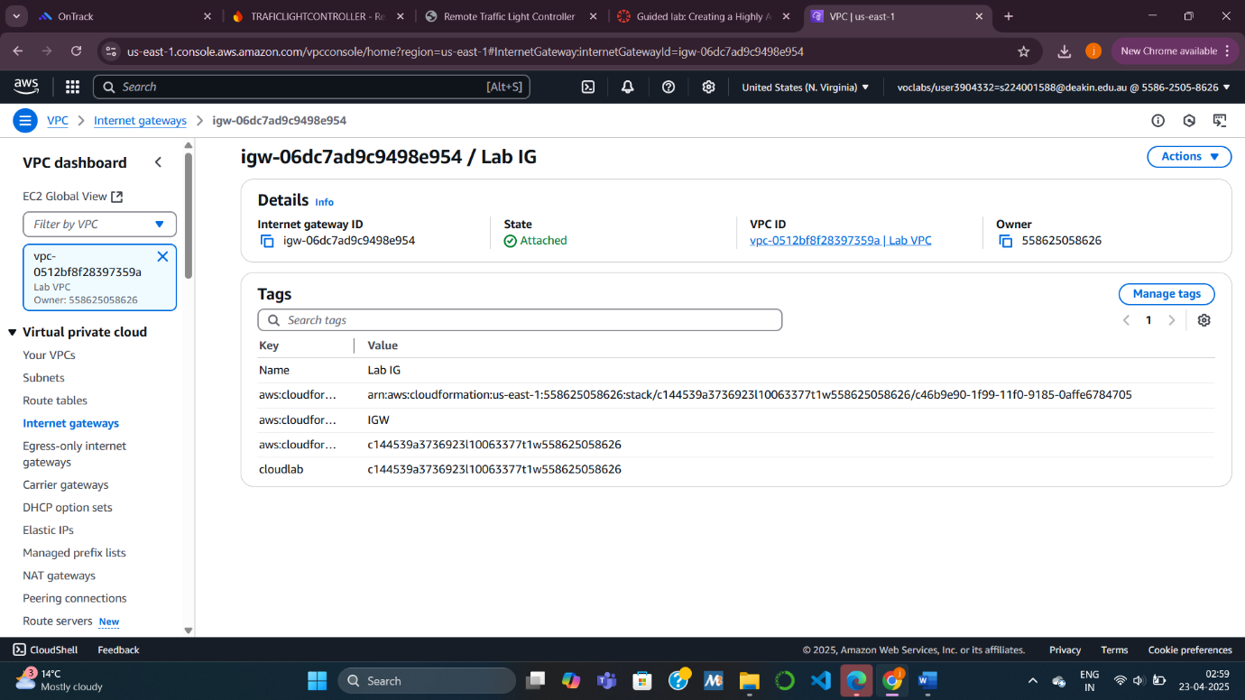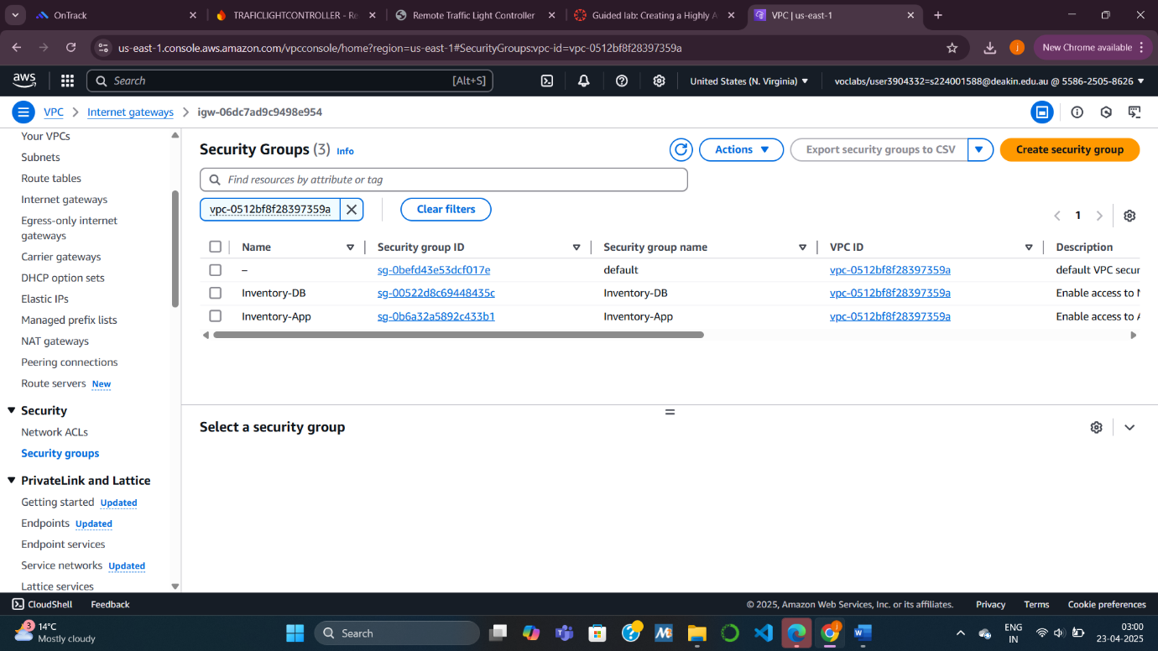

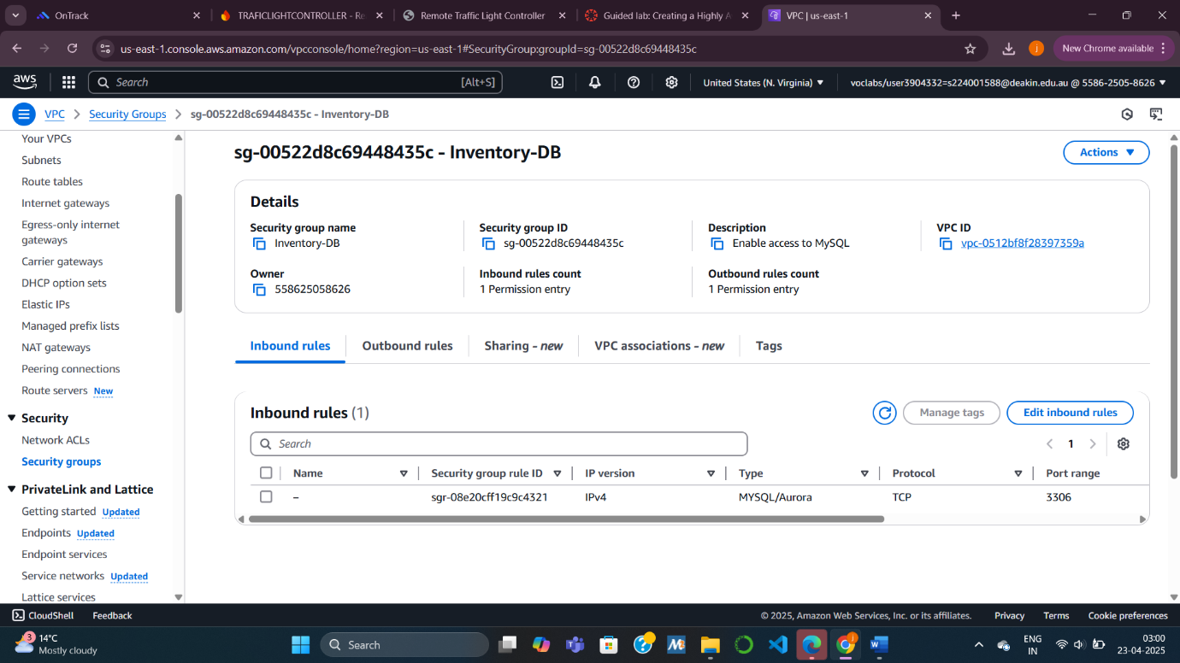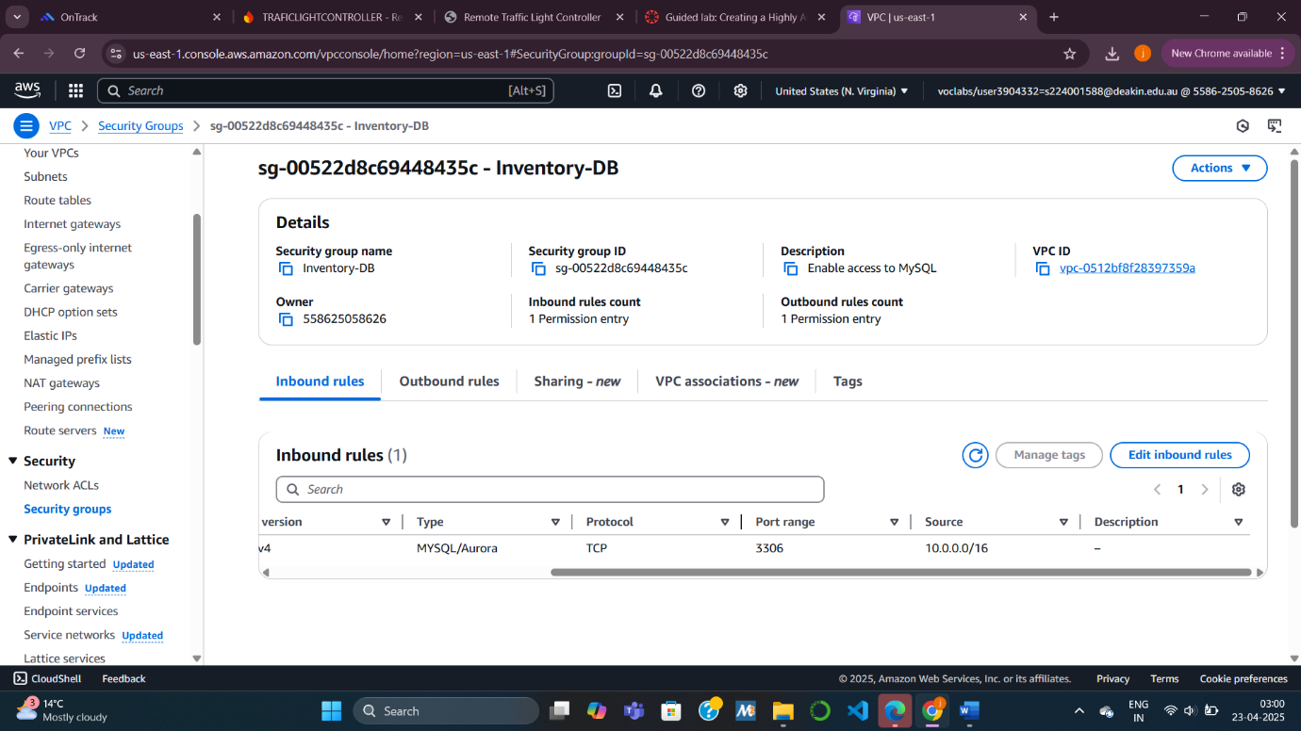

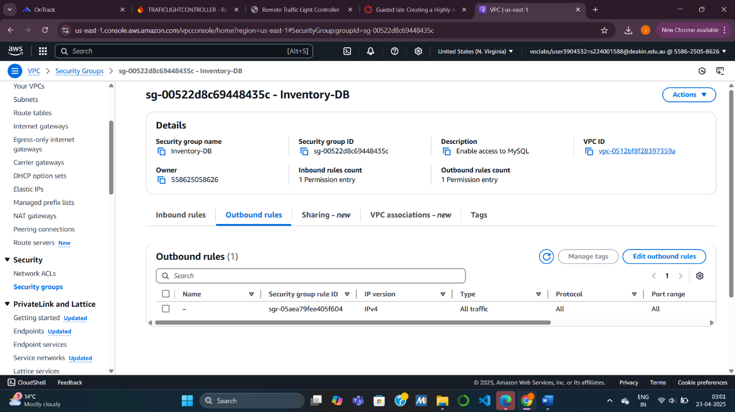

**Task 2: Creating an Application Load Balancer (ALB)**

Here, I set up an Application Load Balancer (ALB) to distribute traffic across multiple instances. I configured the ALB to operate in two public subnets (each in different Availability Zones), ensuring resilience against data center failures. I also created a new security group (Inventory-LB) to allow HTTP and HTTPS traffic. A Target Group (Inventory-App) was configured with health check settings to continuously monitor the health of EC2 instances. This task ensured that incoming traffic would only be directed to healthy application servers, contributing to the high availability of the application.

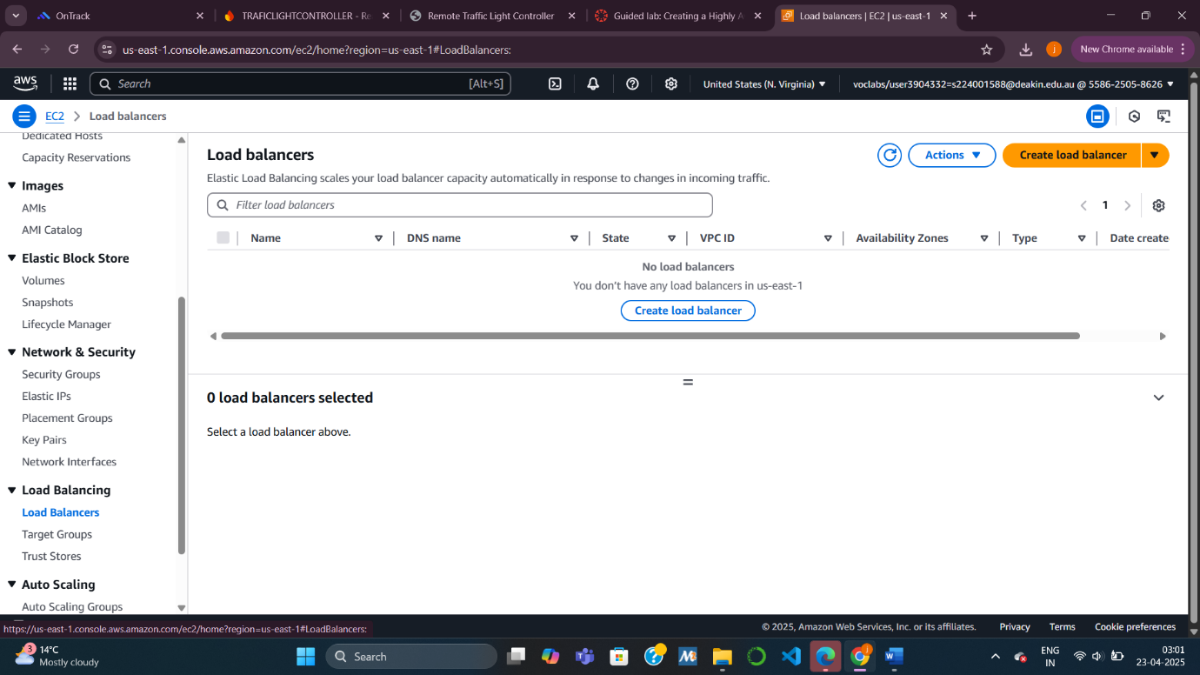J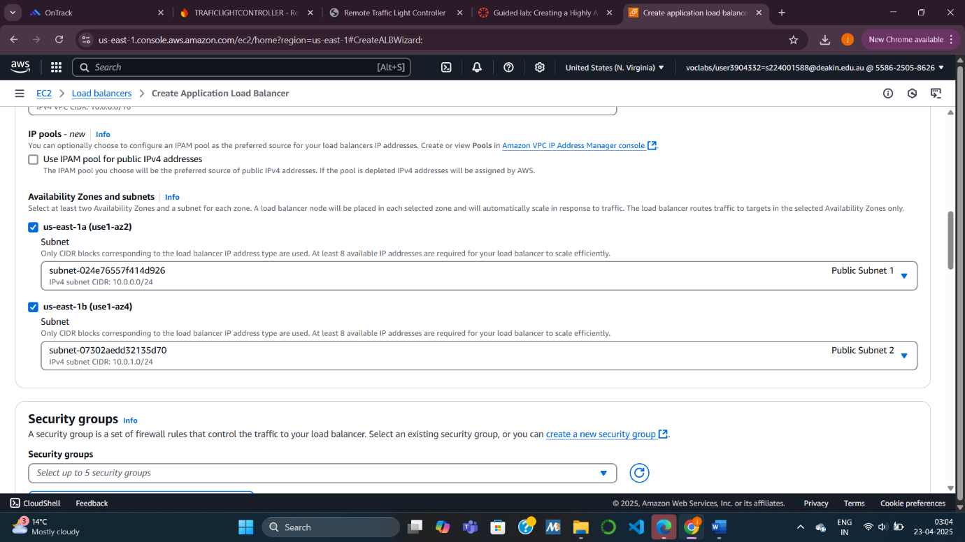

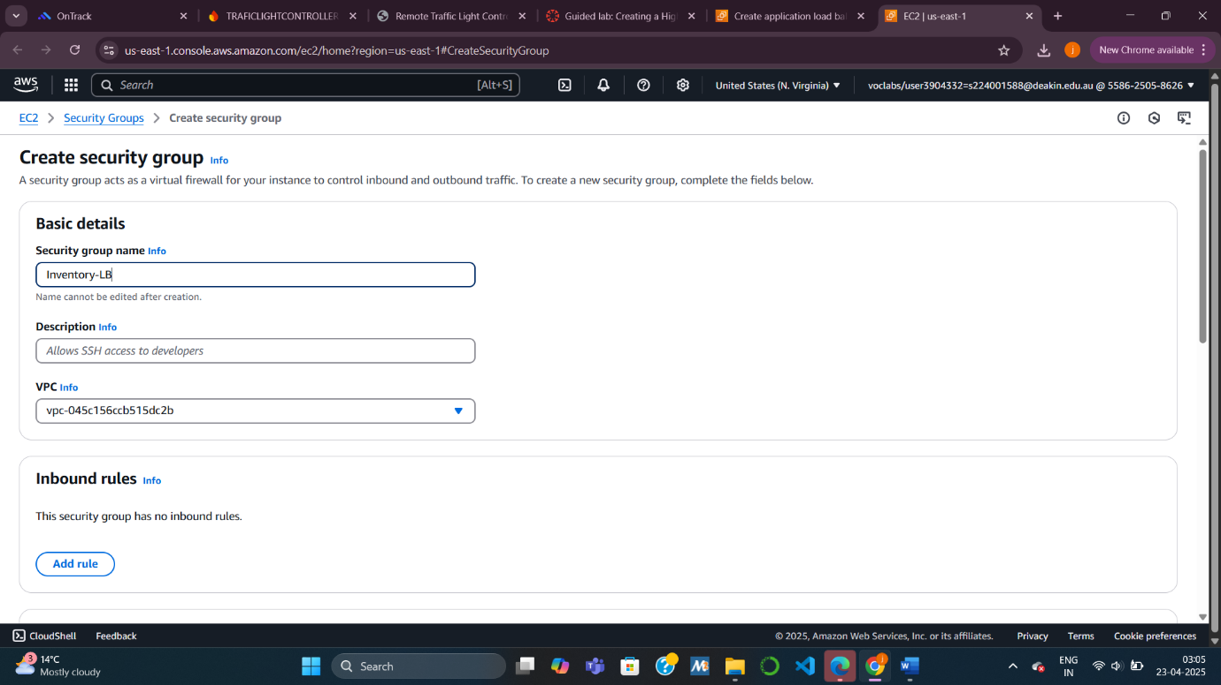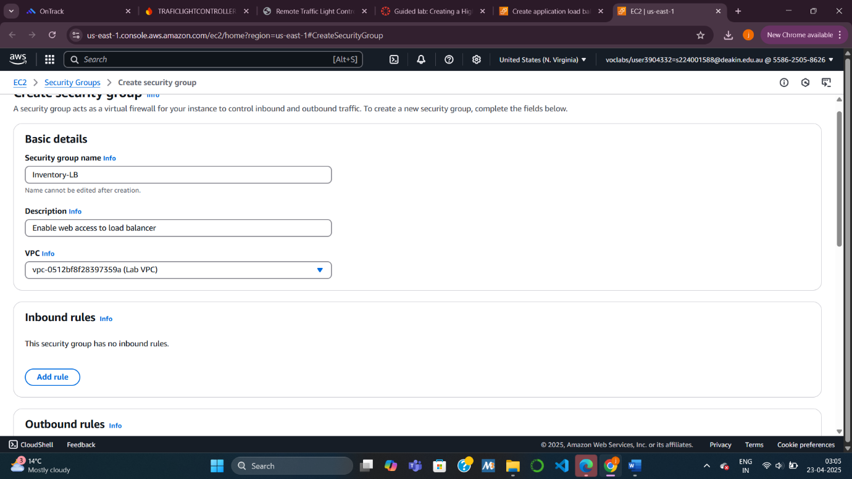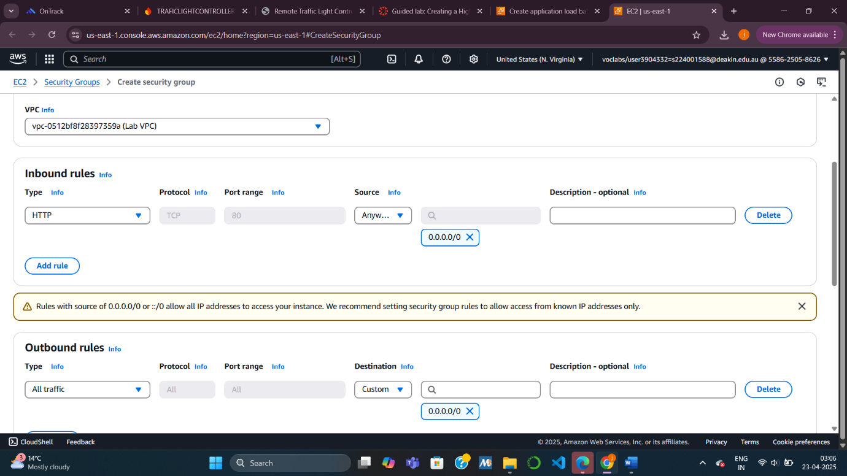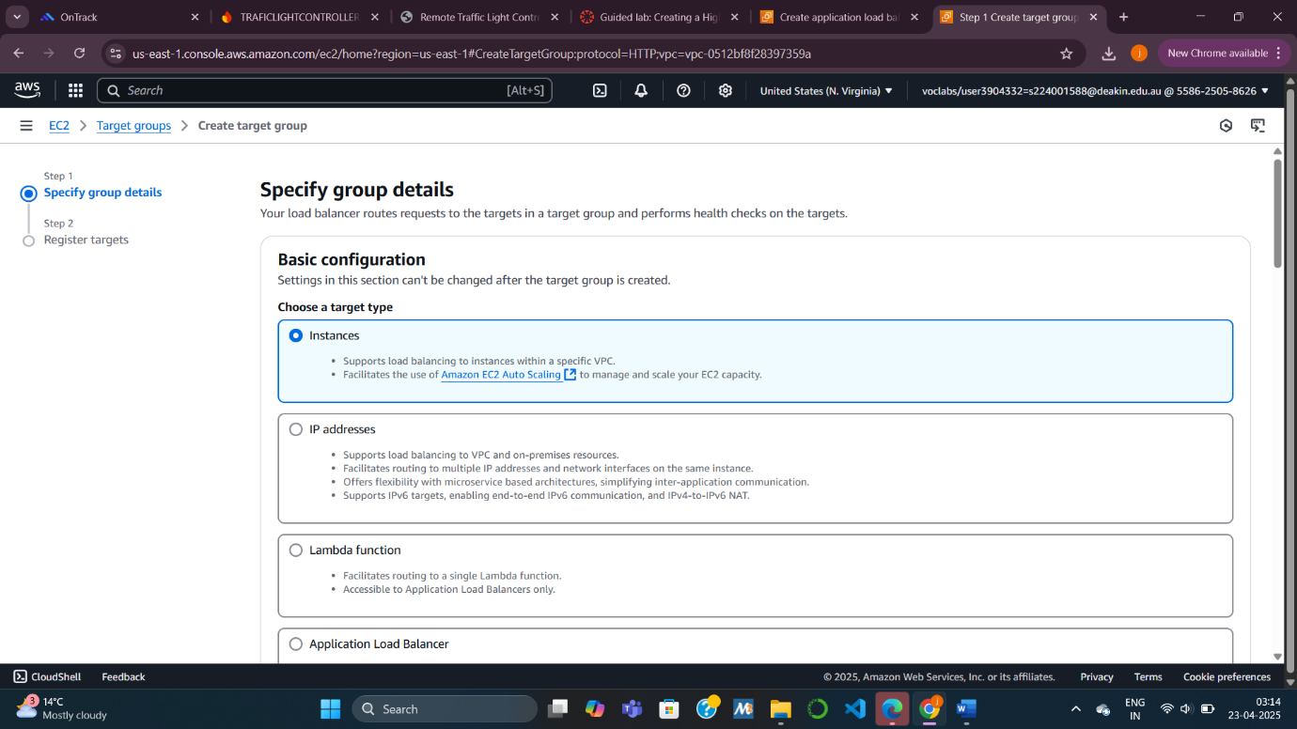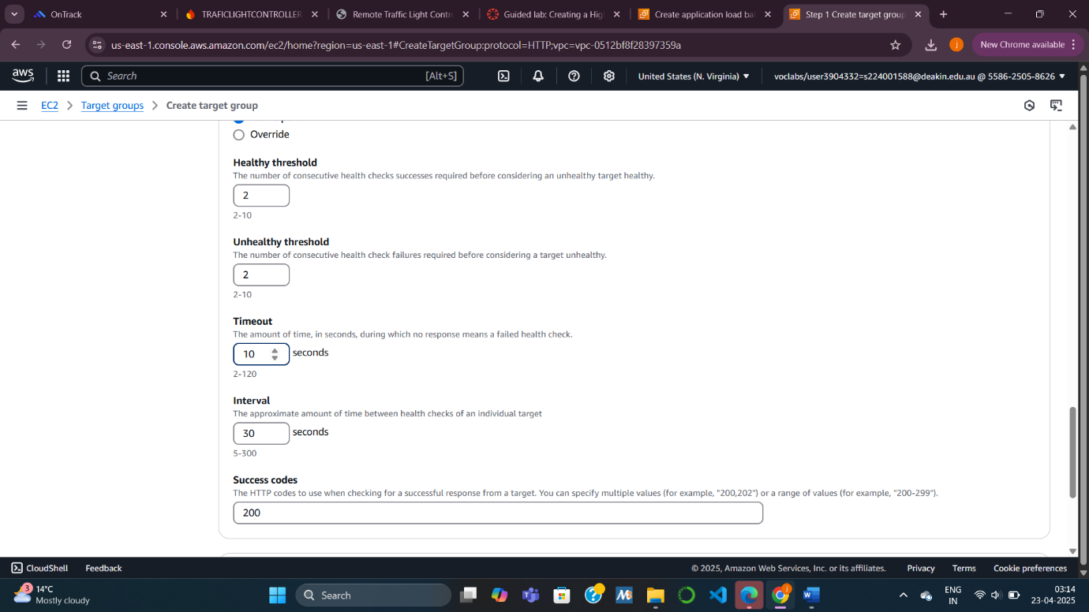  
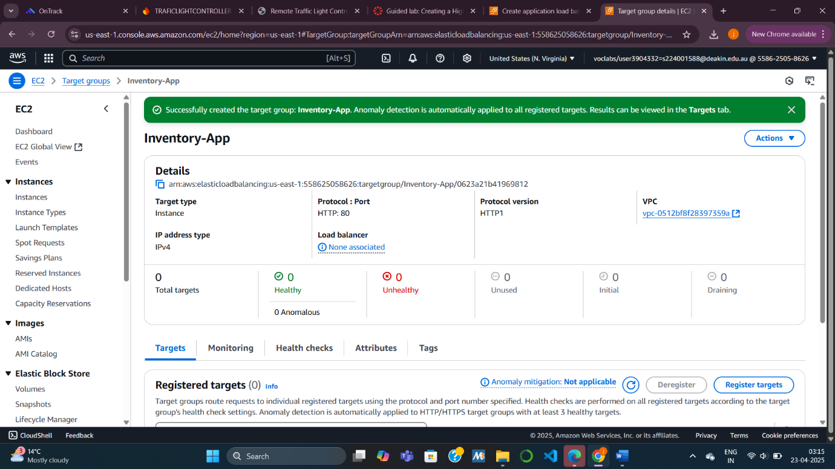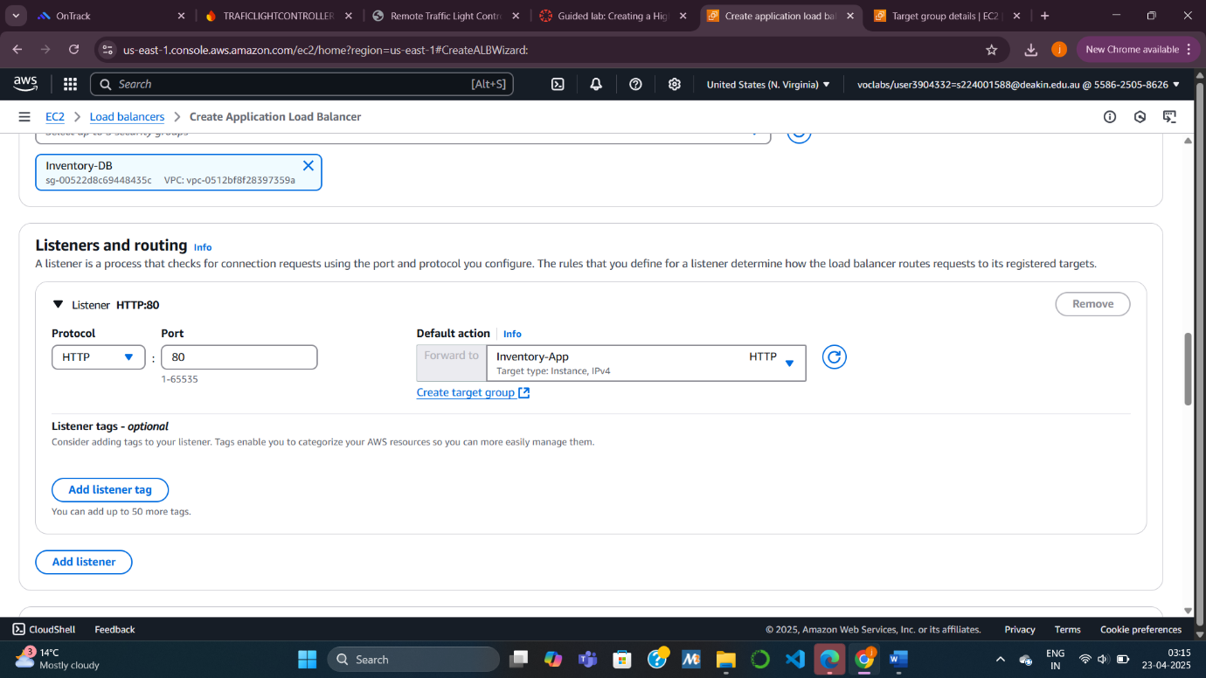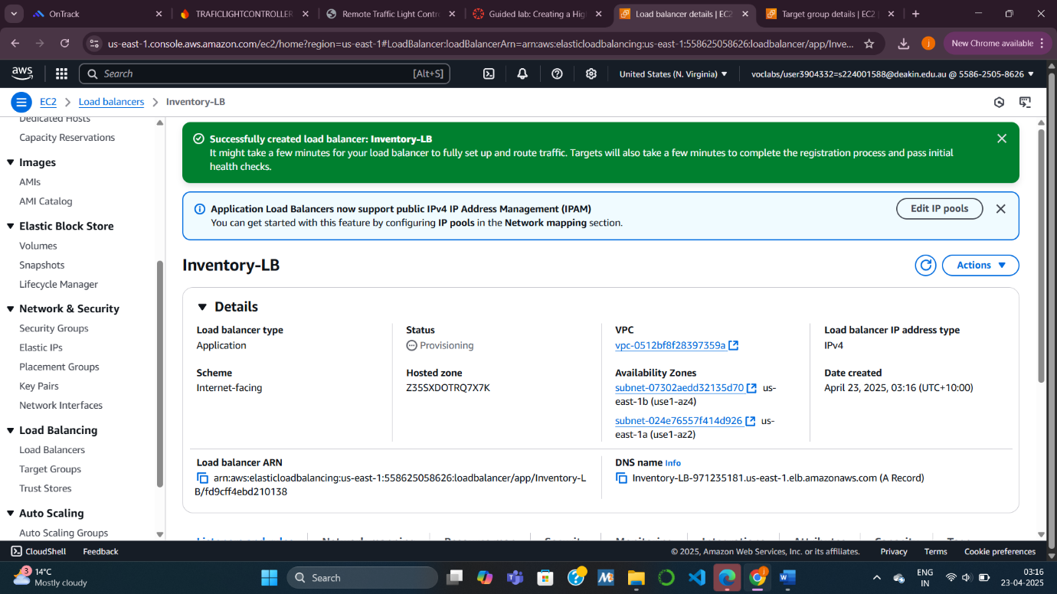 **Task 3: Creating an Auto Scaling Group**

**Task 3.1: Creating an AMI for Auto Scaling**

I created an Amazon Machine Image (AMI) from the existing Web Server 1. This AMI captured the configuration of the instance, allowing me to launch identical instances through the Auto Scaling group later.

**Task 3.2: Creating a Launch Template and an Auto Scaling Group**

Using the AMI, I created a Launch Template (Inventory-LT) specifying details like instance type, key pair, IAM role, and user data to automate server setup. Then, I created an Auto Scaling Group (Inventory-ASG) configured to maintain two EC2 instances across two private subnets. The group was attached to the previously created Target Group (Inventory-App). This ensured that instances were automatically launched, monitored, and replaced in case of failure, supporting continuous application availability.

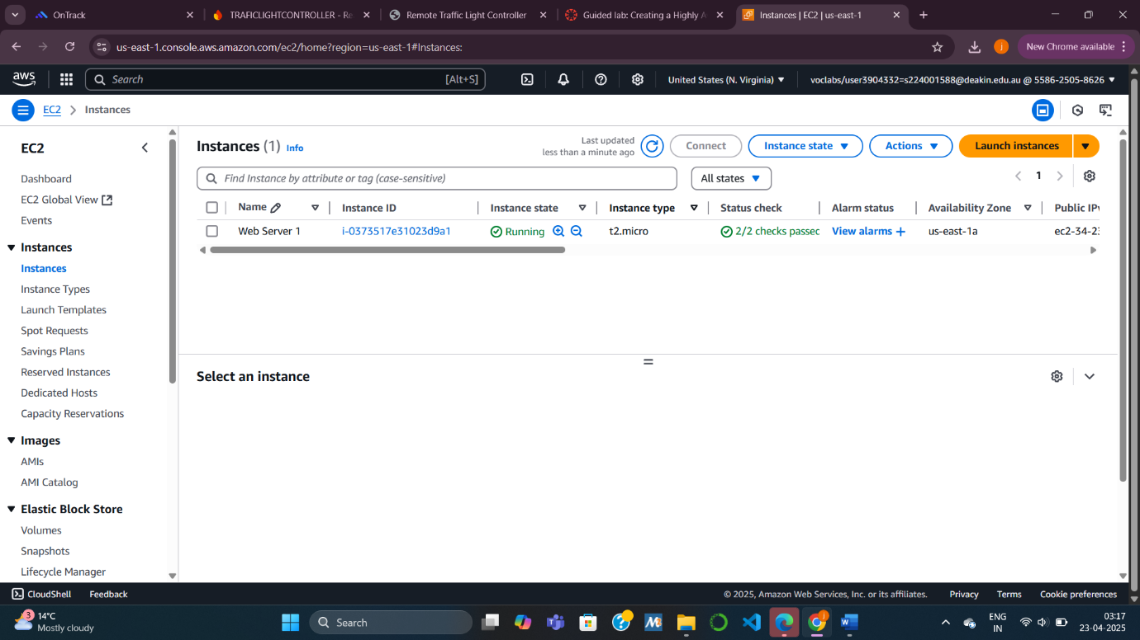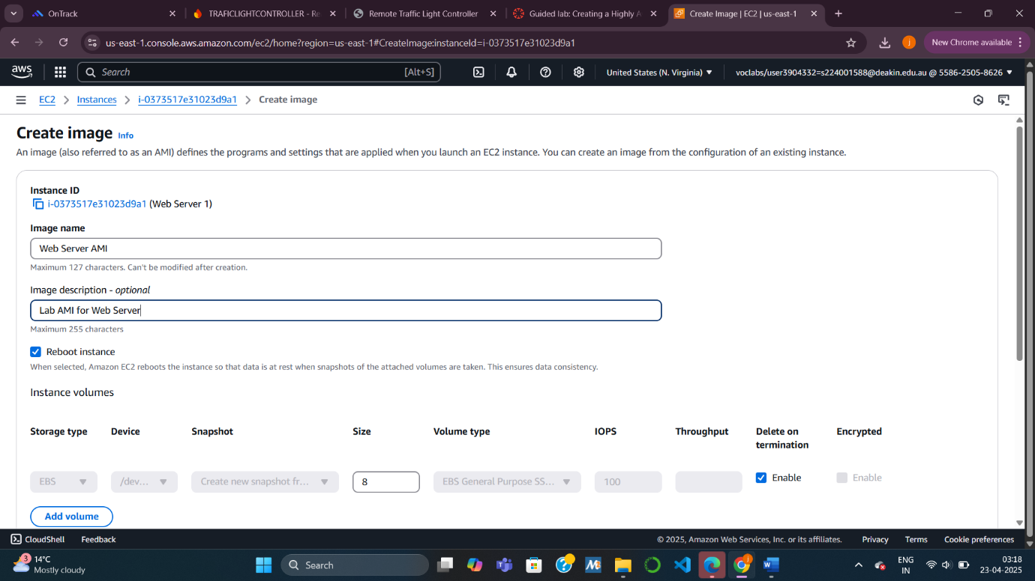

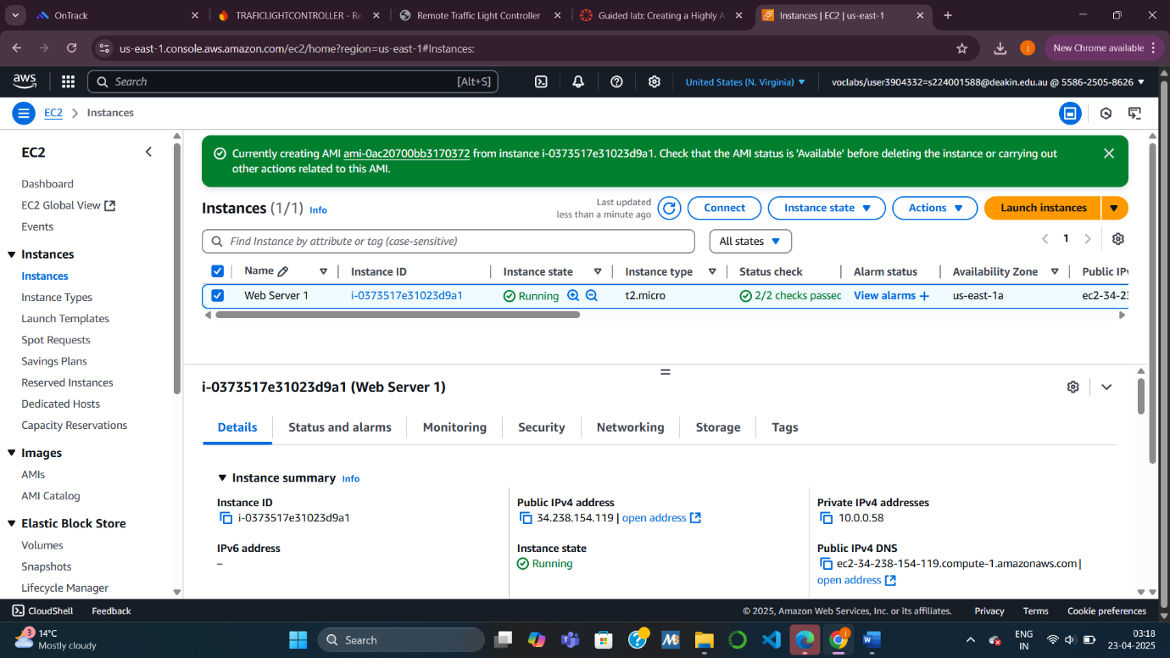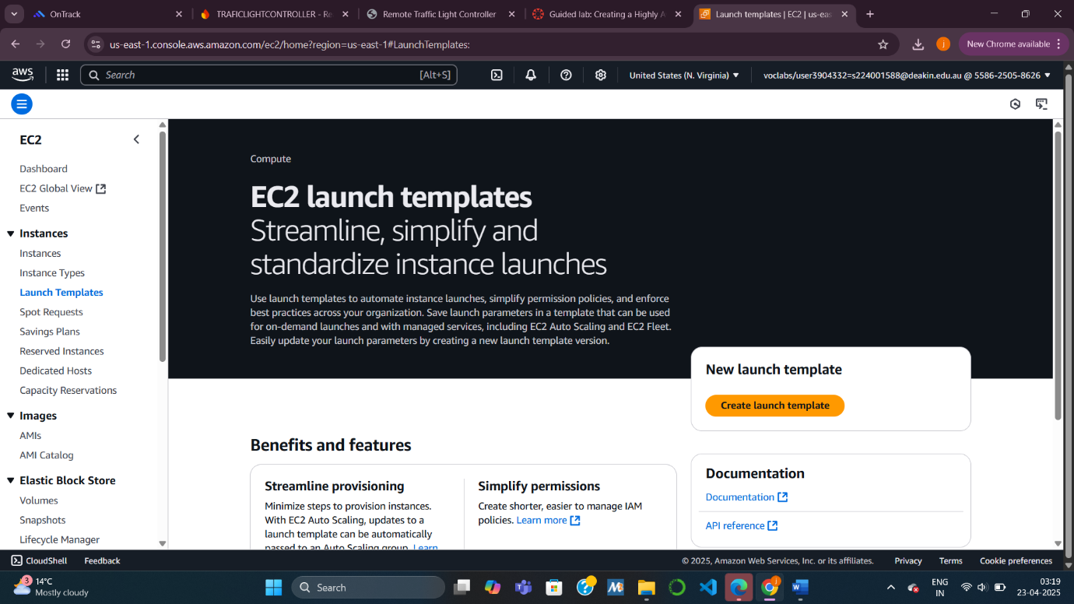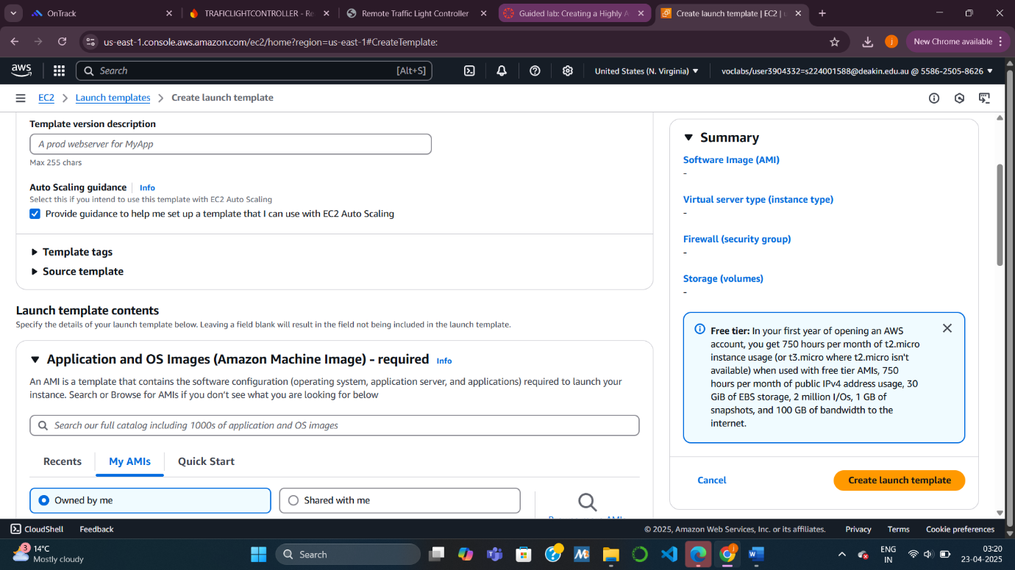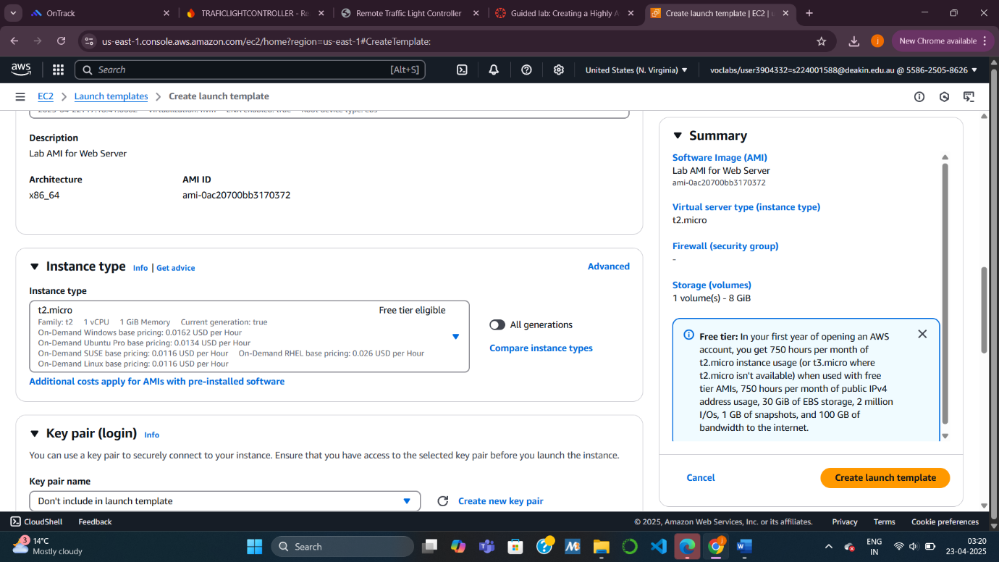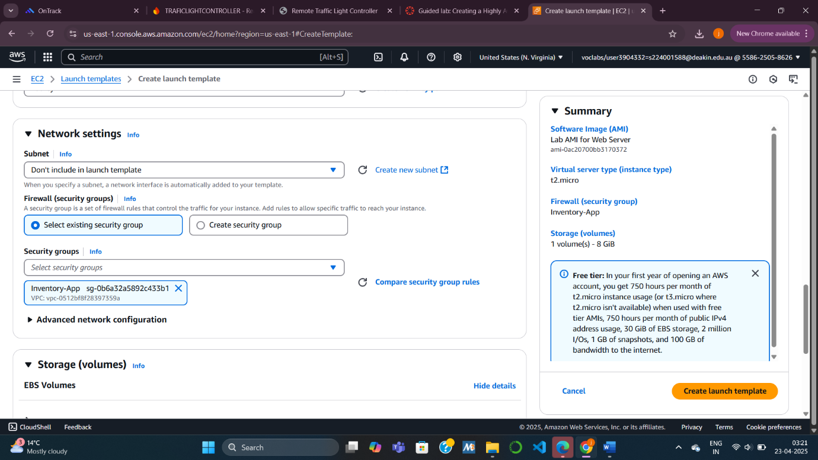

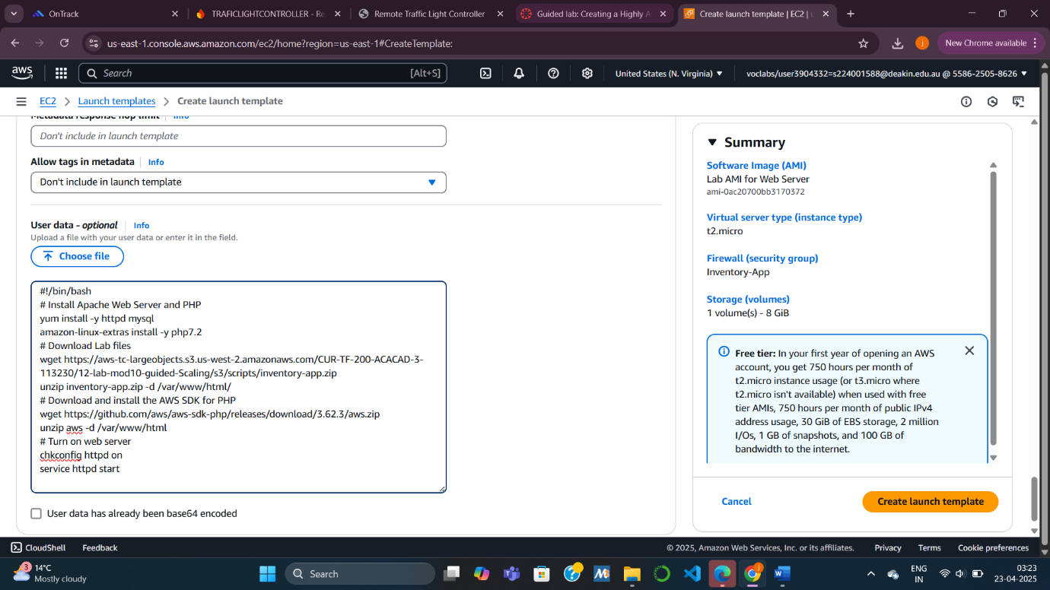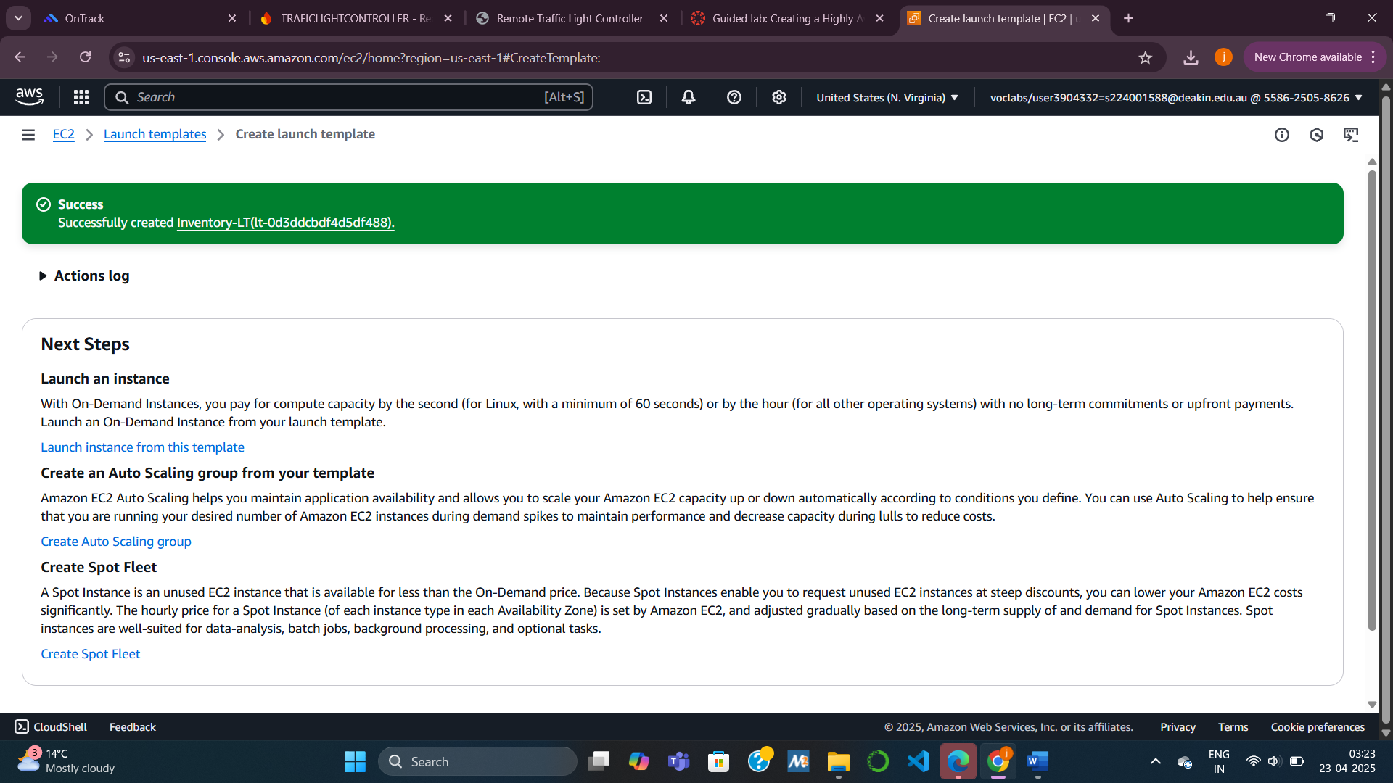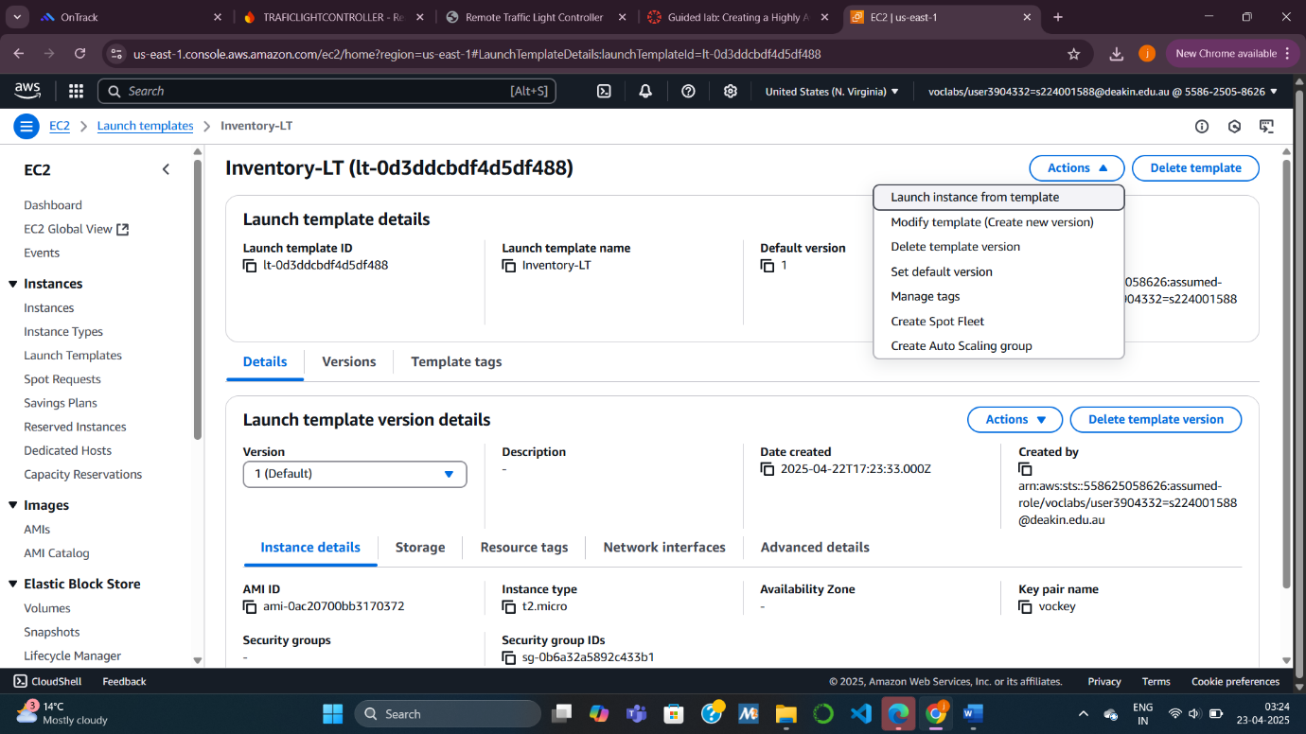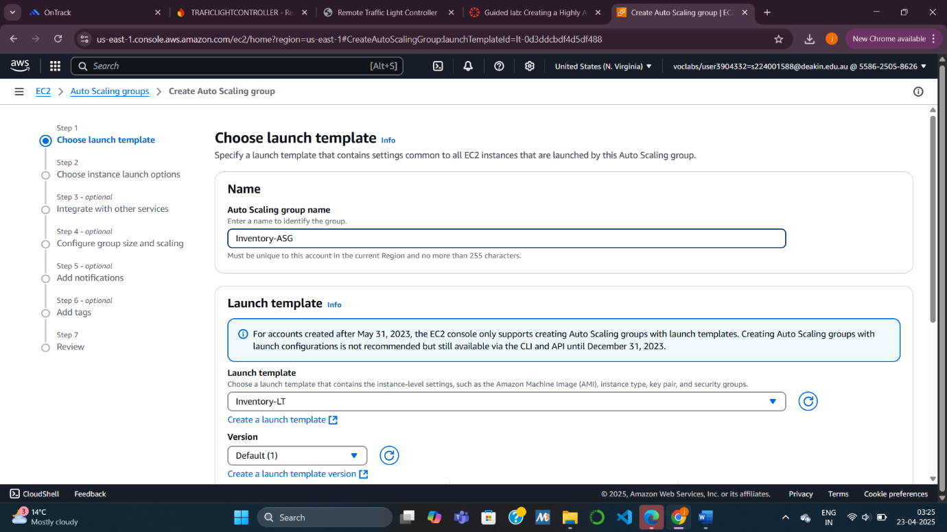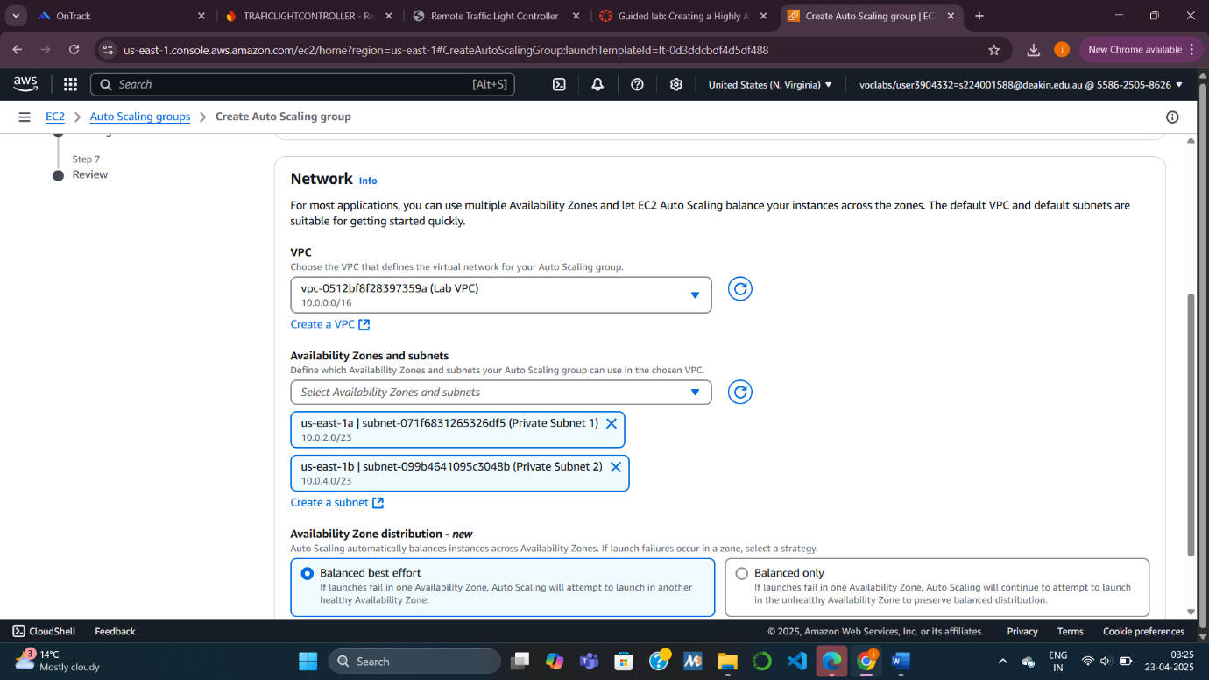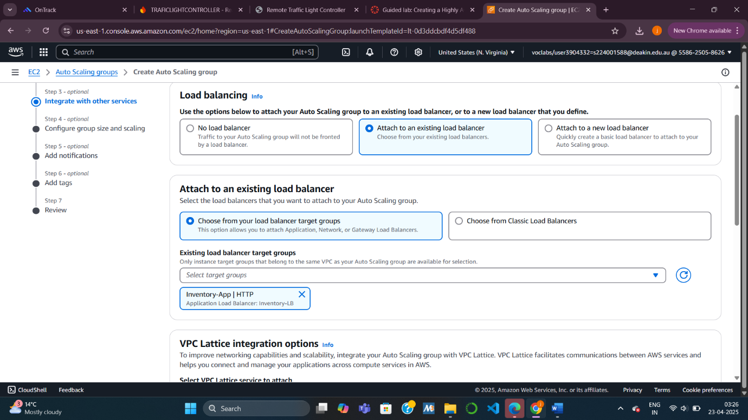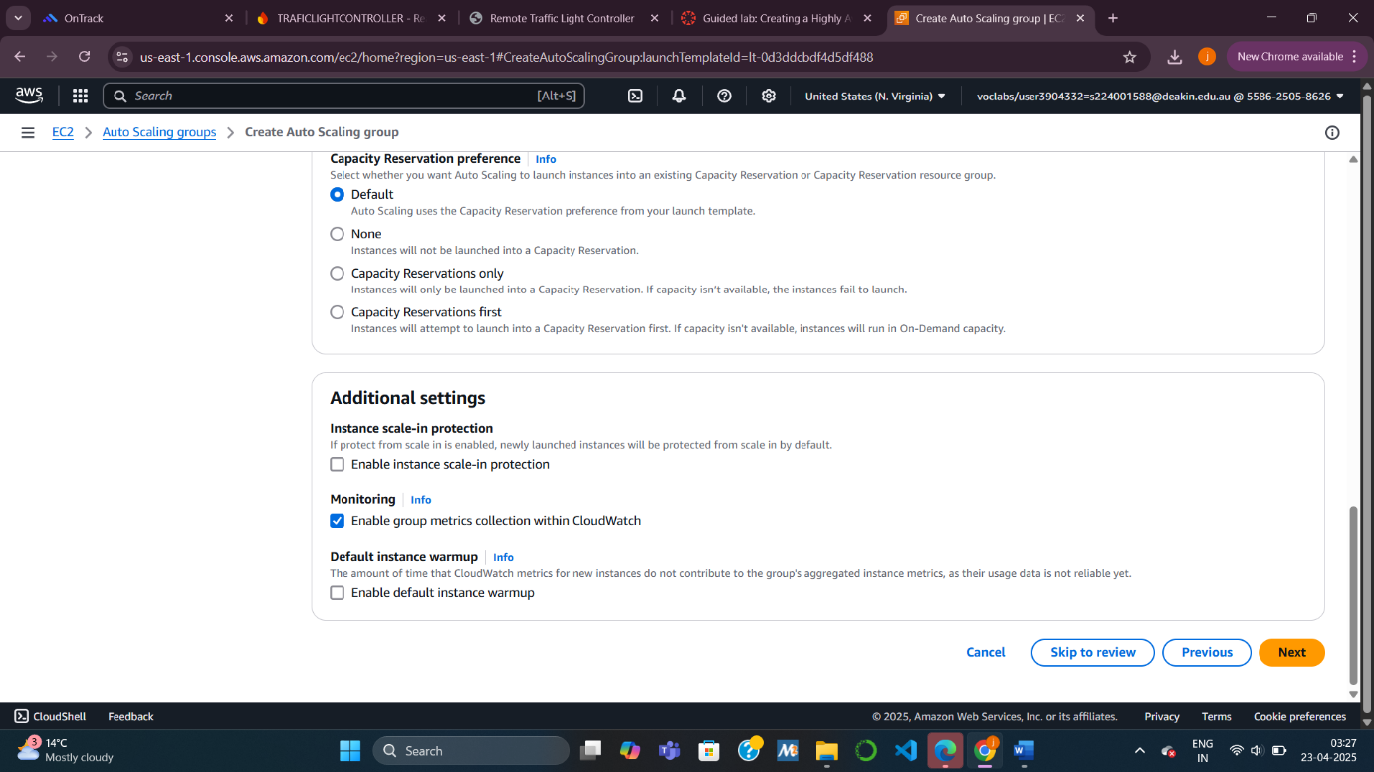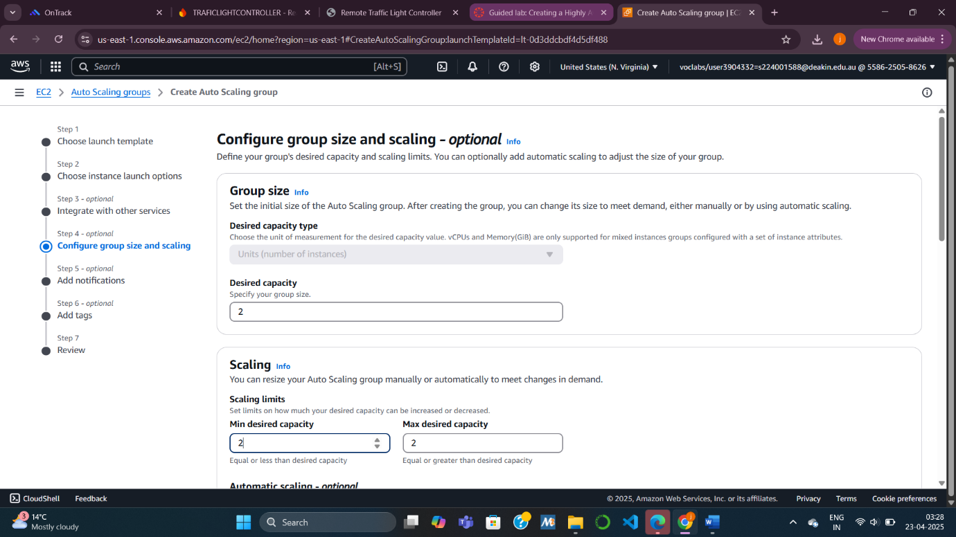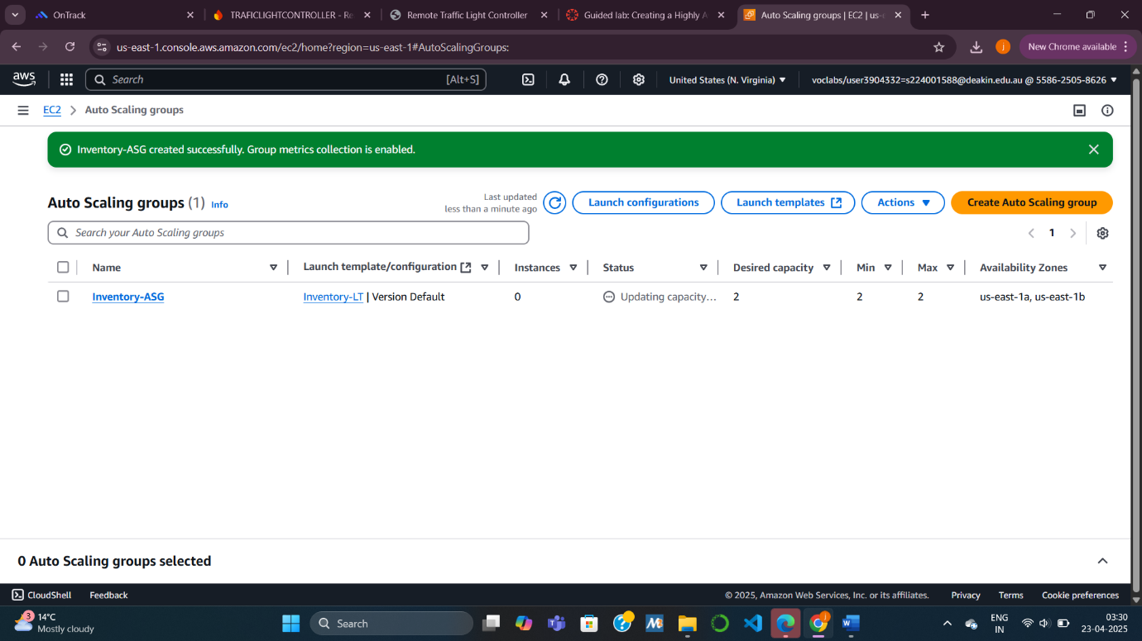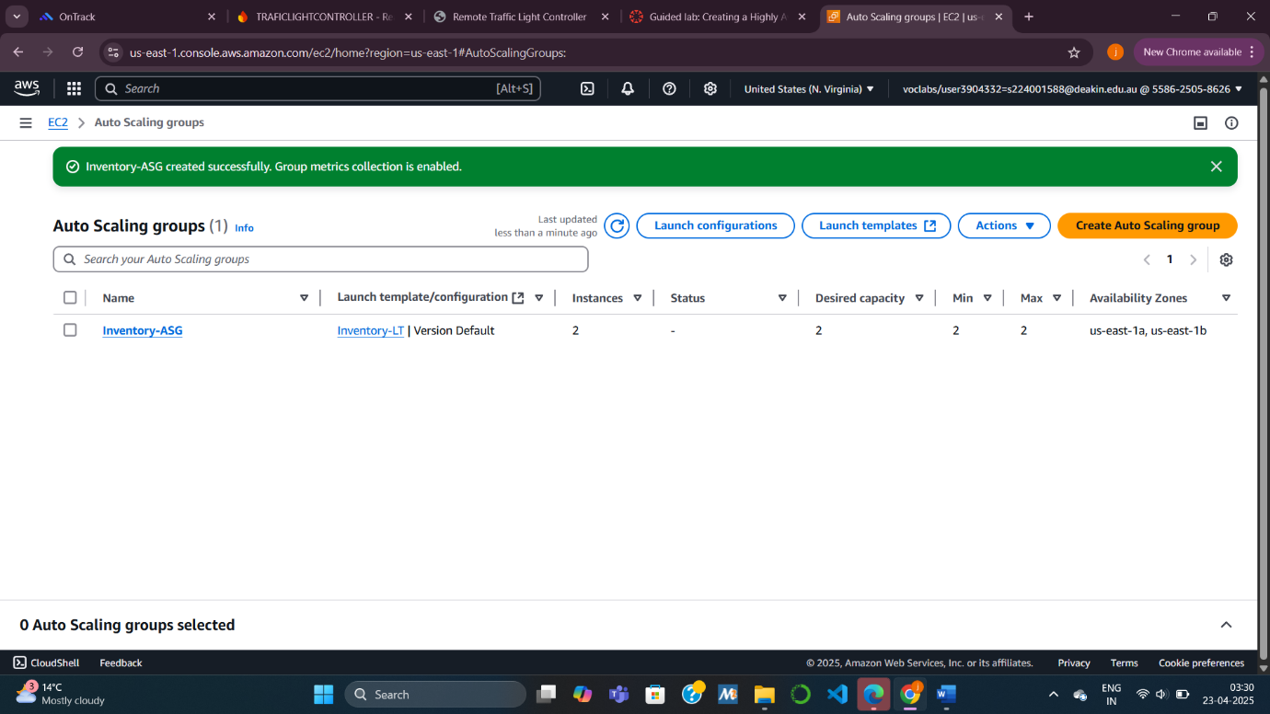 **Task 4: Updating Security Groups**

**Task 4.1: Configuring the Load Balancer Security Group**

I verified that the Load Balancer’s Security Group (Inventory-LB) was set to allow HTTP and HTTPS traffic from external sources. This group facilitates client communication with the application.

**Task 4.2: Configuring the Application Security Group**

The Application Security Group (Inventory-App) was configured to accept incoming HTTP traffic only from the Load Balancer Security Group. This prevents direct access to the EC2 instances from the internet, enforcing a secure tiered architecture.

**Task 4.3: Configuring the Database Security Group**

I updated the Database Security Group (Inventory-DB) to only allow MySQL (port 3306) traffic from the Application Security Group. This enforced the principle of least privilege by restricting database access solely to the application layer.

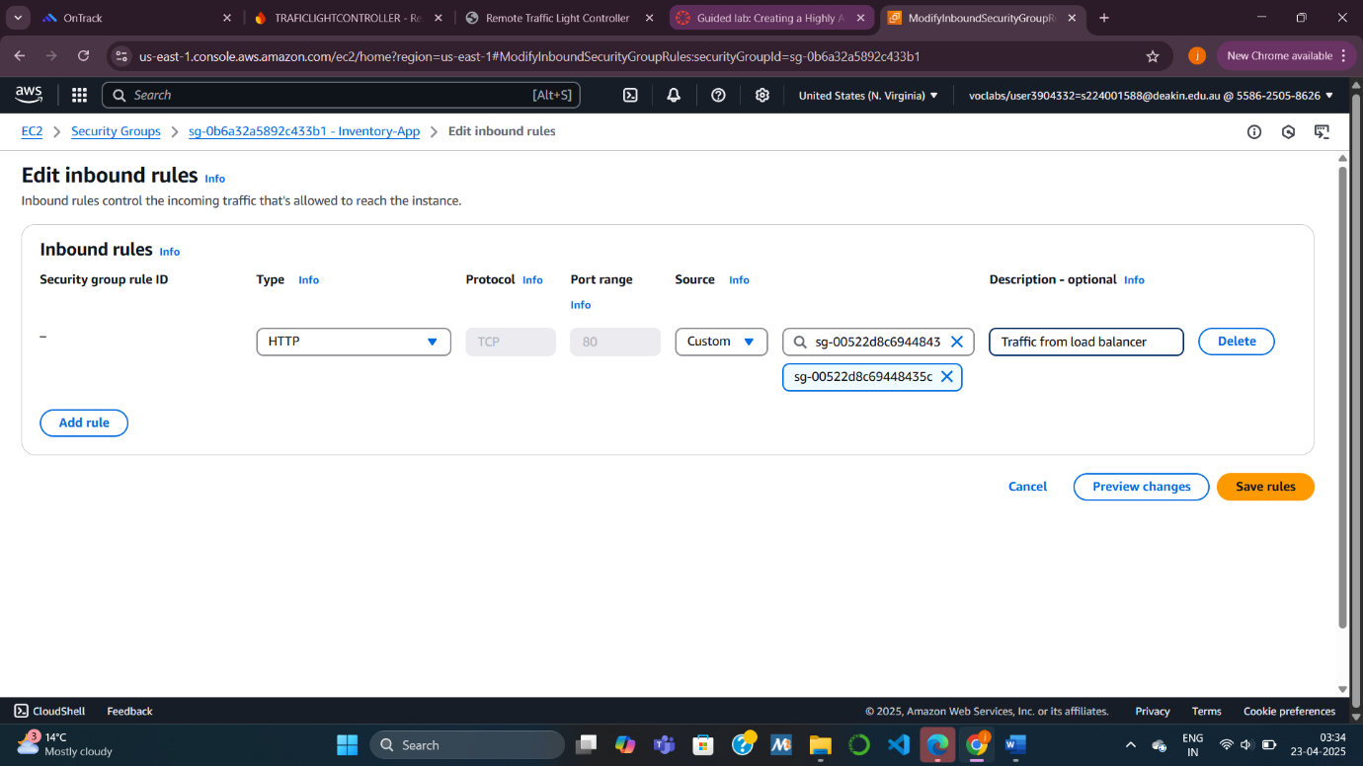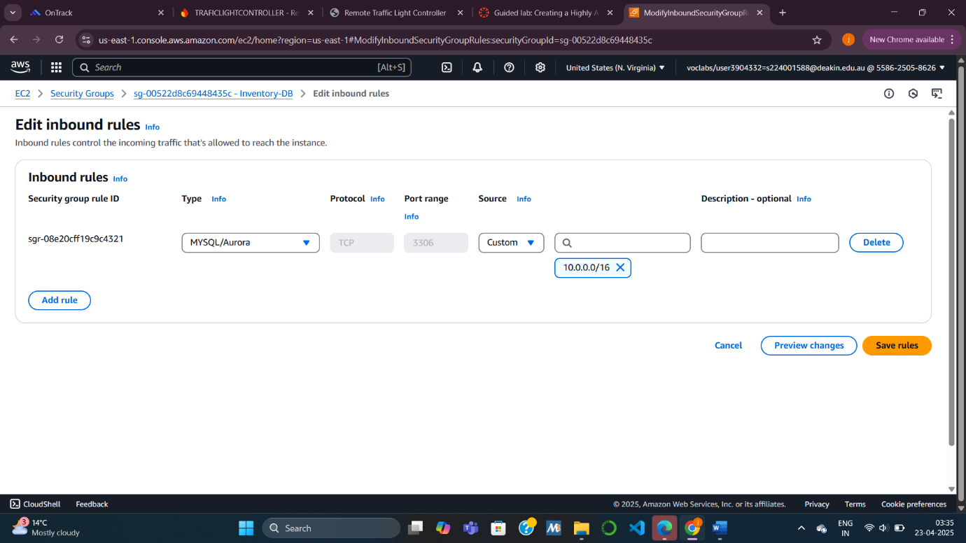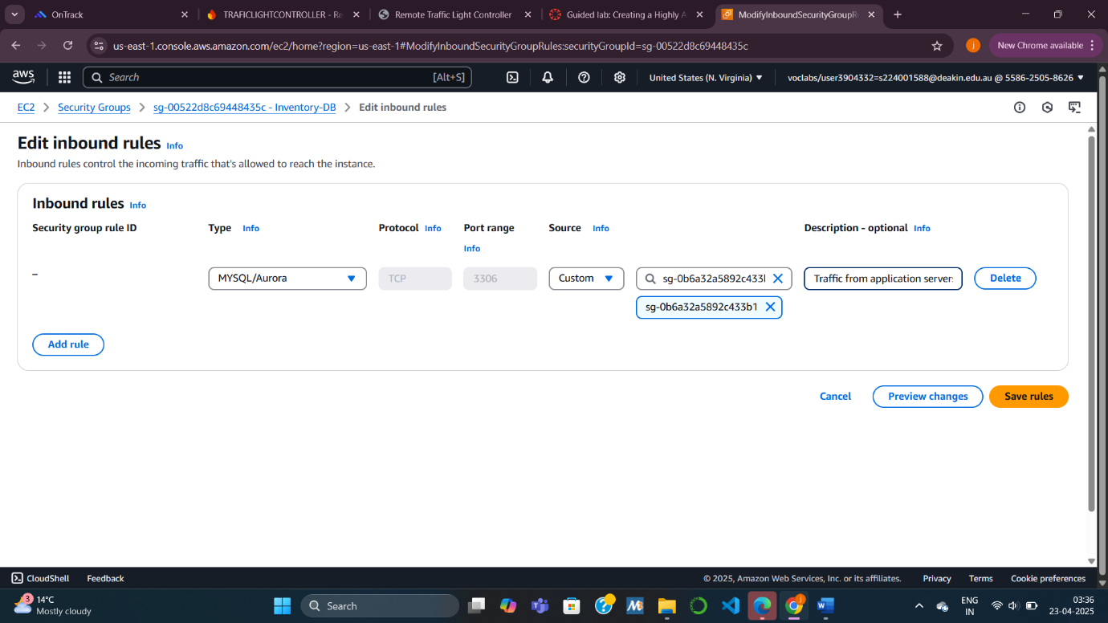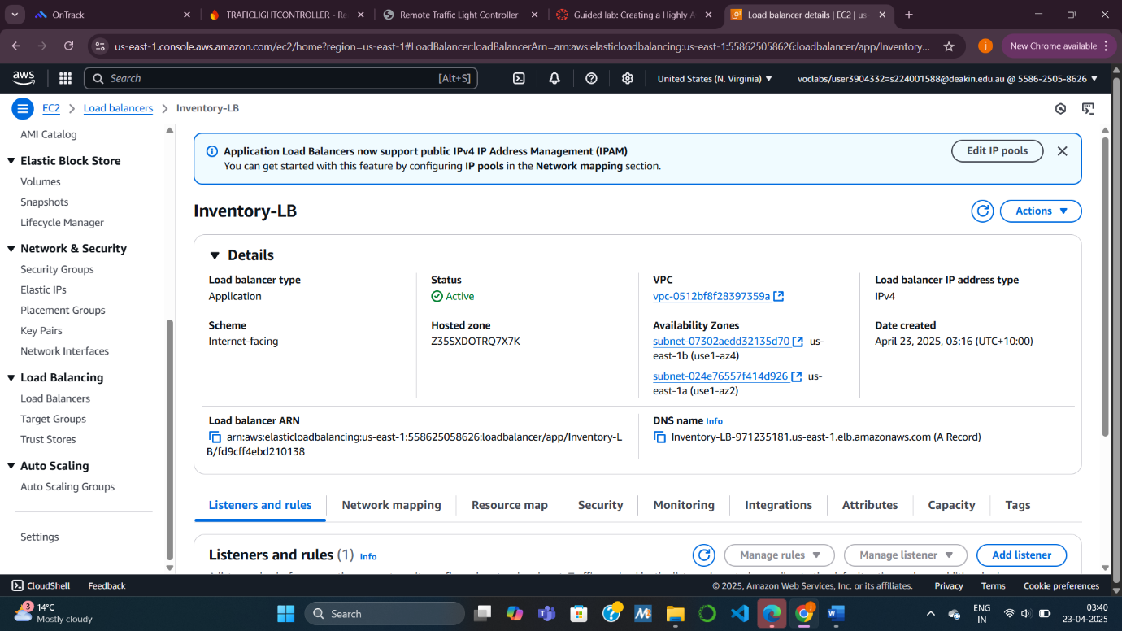 Task 5: Testing the Application

In this task, I verified that the application was properly deployed and reachable through the Load Balancer’s DNS. I confirmed that the Target Group registered two healthy EC2 instances and tested the Load Balancer by accessing the application’s web page. Reloading the page showed load distribution between the two instances, proving correct setup and functionality.

Additionally , To simulate a failure scenario, I terminated one of the application’s EC2 instances. The Load Balancer detected the failure and routed traffic to the remaining healthy instance without service interruption. The Auto Scaling Group automatically launched a replacement instance to maintain the desired instance count. This test validated the effectiveness of the high availability setup.

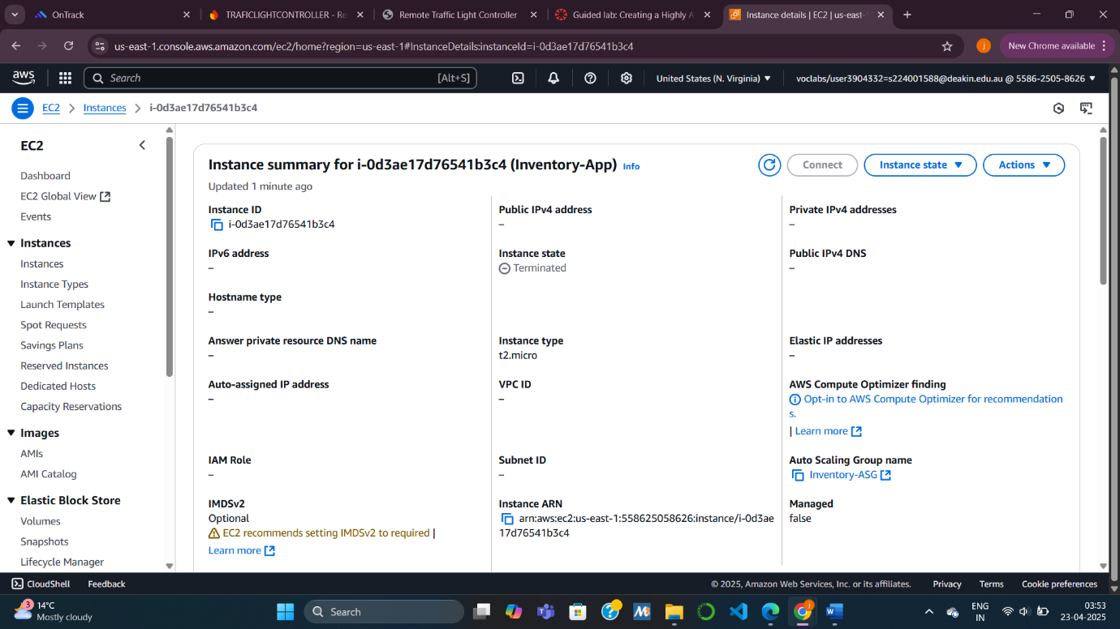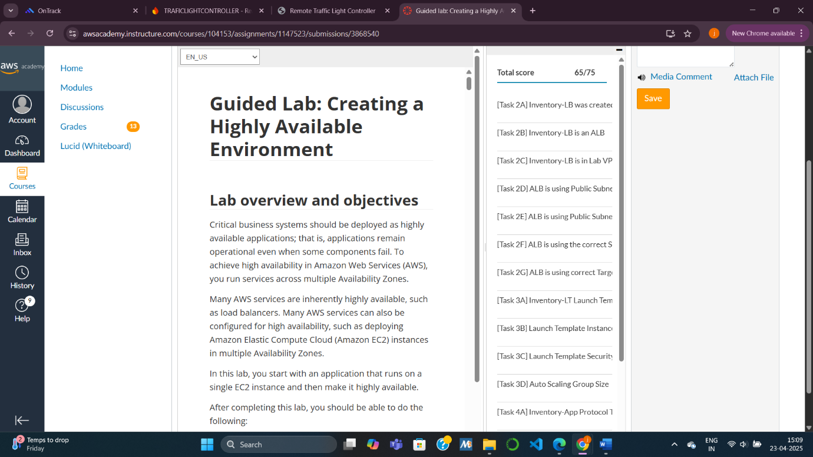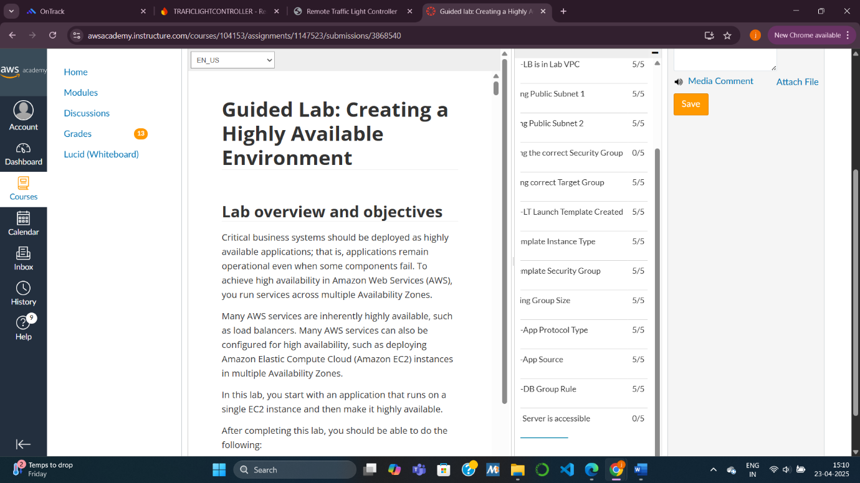

WHAT WENT WRONG ?

**Problem 1: Load Balancer Security Group is Incorrect**

**What Went Wrong:**

* The Load Balancer (Inventory-LB) was **not assigned the correct Security Group**.
* The Security Group attached to the Load Balancer is **not named or configured as "Inventory-LB" Security Group** as expected.
* Security Groups act like virtual firewalls for your instances and Load Balancer — if these aren’t configured correctly, the application won’t be reachable.

**How to Rectify :**

1. **Identify the Correct Security Group:**
   * Make sure there is a dedicated Security Group created for the Load Balancer named properly (e.g., Inventory-LB).
   * This Security Group should allow **incoming HTTP/HTTPS traffic (TCP port 80 and/or 443)** from anywhere (0.0.0.0/0) or your allowed IP ranges.
2. **Check Security Group Attachment:**
   * When creating or configuring the Load Balancer, explicitly **attach the correct Security Group** (Inventory-LB group).
   * Verify this in the AWS Console under **EC2 → Load Balancers → Select your LB → Description → Security Groups**.
3. **Double-Check Inbound and Outbound Rules:**
   * Inbound Rule:
     + Allow HTTP (Port 80) and/or HTTPS (Port 443).
   * Outbound Rule:
     + Allow all outbound traffic (default is usually fine unless restricted).

**Problem 2: Application is Not Reachable (Possible Subnet or Instance Issue)**

**What Went Wrong:**

* Even though your Load Balancer is in **public subnets**, the system reports that **the application is not reachable**.
* The issue may relate to **subnet configuration, Security Group settings, or unhealthy target instances**.

**How to Rectify :**

1. **Verify Public Subnet Settings:**
   * Ensure the subnets used by the Load Balancer are:
     + Marked as **public** (i.e., have a Route Table with a route to the **Internet Gateway**).
   * Check subnet settings under **VPC → Subnets → Route Table → Routes**.
2. **Check Auto Scaling Group and Target Group Health:**
   * Confirm that **two healthy instances** are running in the Auto Scaling Group.
   * Check that the **Target Group health check path** is correct (e.g., /index.html or /health endpoint).
   * Instances must respond successfully to the health check; otherwise, they will be marked as **unhealthy**.
3. **Instance Security Group Rules:**
   * The Security Group attached to your EC2 instances (through Launch Template or Auto Scaling Group) **must allow inbound traffic from the Load Balancer Security Group** on the application port (usually TCP port 80).
   * Example:
     + Inbound Rule:
       - Type: HTTP
       - Source: **Inventory-LB Security Group ID**
4. **Confirm Web Server is Running:**
   * Ensure that the EC2 instances are actually **running the web server** (like Apache, Nginx, etc.) and listening on the correct port.

TO SUMMARIZE:

* Ensure the correct Security Group is attached to the Load Balancer with proper inbound rules (HTTP/HTTPS).

* Verify public subnets are properly routed through an Internet Gateway.

* Confirm that the Auto Scaling Group is launching healthy instances.

* Double-check that instances accept traffic from the Load Balancer's Security Group on the correct port.

* Validate the web server is running and reachable on the target instances.

* Always test instance health and Load Balancer reachability before submission.

Task Questions

* What is an AWS Region and Availability Zone? How are they related?

An **AWS Region** is a geographical area containing multiple isolated **Availability Zones (AZs)**. An AZ is one or more separate data centers with independent power, networking, and cooling within a Region. They are related because multiple AZs within a Region enable high availability and fault tolerance for applications.

* What are the different types of Elastic Load Balancer?

The three types of Elastic Load Balancers (ELB) in AWS are:

**Application Load Balancer (ALB):** Used for HTTP/HTTPS traffic with Layer 7 features like path-based and host-based routing.

**Network Load Balancer (NLB):** Designed for TCP/UDP traffic, providing high performance and ultra-low latency at Layer 4.

**Gateway Load Balancer (GWLB):** Used for deploying and managing third-party virtual appliances like firewalls, operating at Layer 3.

* When should you use Application Load Balancer?

Use **Application Load Balancer** when your application requires:

**Advanced request routing** (based on URL path or hostname).

**HTTP/HTTPS traffic handling** with SSL/TLS termination.

**WebSocket support** and routing to containers (ECS/EKS).

**Sticky sessions** or need for Layer 7 features like redirects or fixed responses.

It is ideal for **web applications** where content-based routing is needed.

* How do you make an RDS highly available?

To make Amazon RDS highly available, use **Multi-AZ deployments**. This automatically creates a standby replica in a different Availability Zone and enables failover in case of instance failure, ensuring continuous database operation.

KNOWLEDGE CHECK :

